3.3 I can set up and use access rights to enable others to access information.

In this document I will demonstrate how I uploaded Unit 3 to my Dropbox account and shared it with Shafiq. I will also talk about the terms and conditions that comes with sites like Dropbox and Google drive.

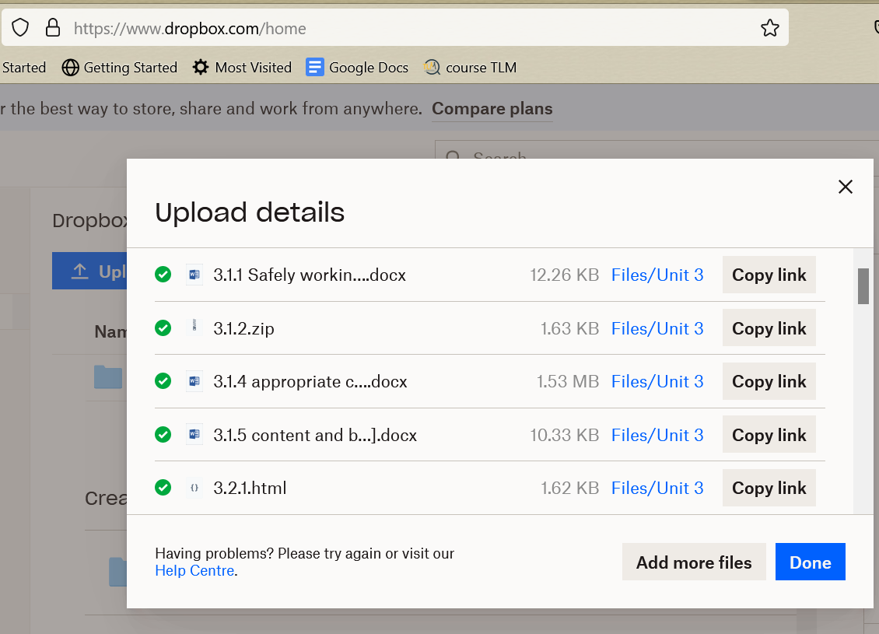

[The above image shows that I have uploaded the files to Dropbox]

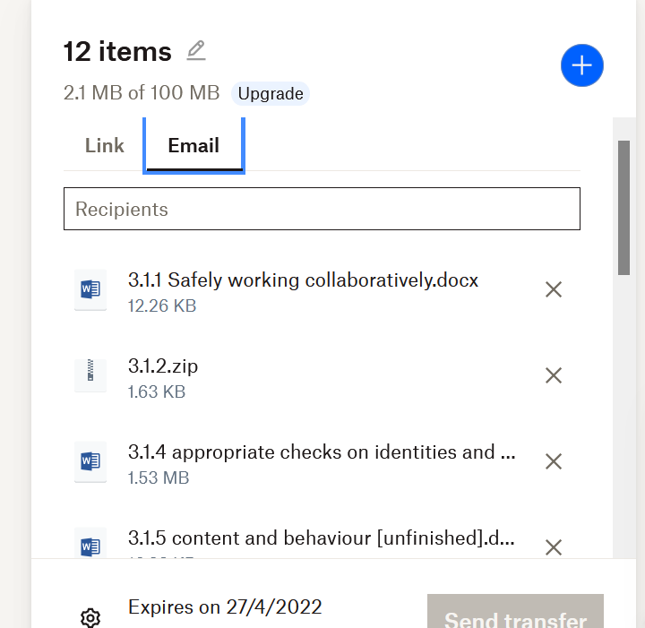

[The above image shows me sharing the files with Shafiq]

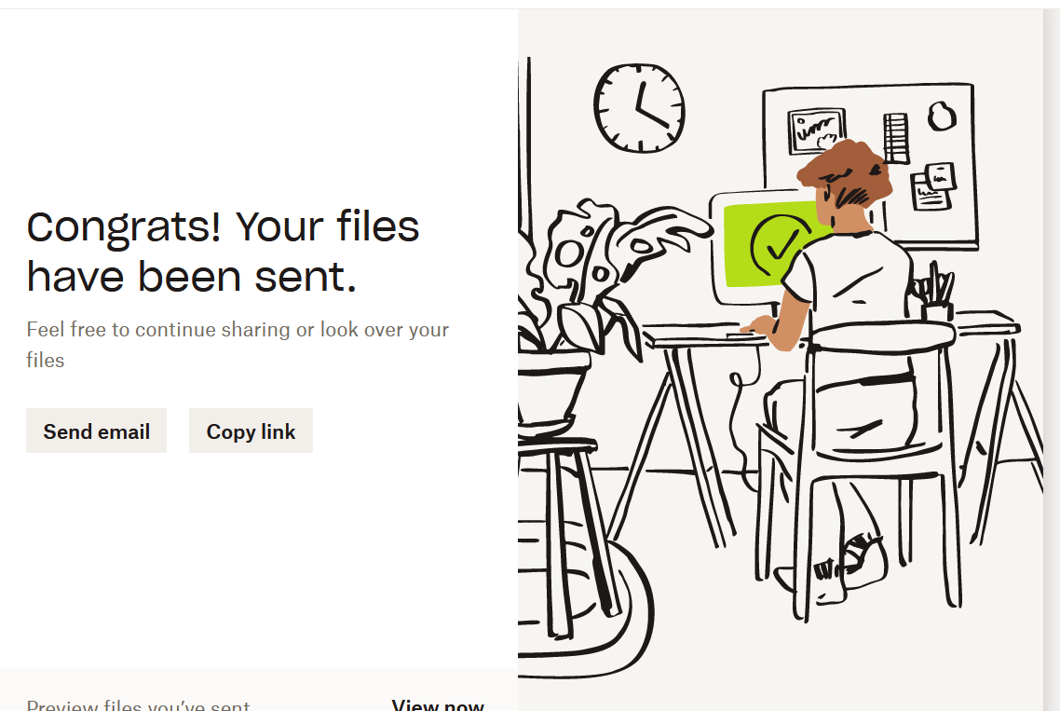

[The above image shows that I have shared the files with Shafiq]

While using Dropbox services I agree to T&Cs that come along with them, that includes Dropbox sharing “cookies and other technologies”. I also agree that they may send me Marketing emails if I don’t opt-out. A lot of the T&Cs include legal terms and terms that will cover Dropbox should anything go wrong and people lose their files and need to contact support or worse yet go to court over the issues.